## A PROJECT REPORT

**on**

**“ONLINE SHOPPING SYSTEM”**

## Submitted to

**KIIT Deemed to be University**

## In Partial Fulfillment of the Requirement for the Award of BACHELOR’S DEGREE IN

**COMPUTER SCIENCE & ENGINEERING BY**

**UNDER THE GUIDANCE OF**

**Dr.Prachet Bhuyan**

**(DEAN,T&P)**



**SCHOOL OF COMPUTER ENGINEERING**

## KALINGA INSTITUTE OF INDUSTRIAL TECHNOLOGY

**BHUBANESWAR, ODISHA - 751024 May 23**

**Acknowledgement**

We are profoundly grateful to **Dr. (Dr).Prachet Bhuyan** of **School of Computer Engineering** at **KIIT University, Bhubaneswar** for his expert guidance and continuous encouragement throughout to see that this project meets its target since its commencement to its completion. We are grateful to him for his guidance, constructive feedback, and constant support throughout the project.

Ayush Srivasta(2106307)

Ayush Kumar Ray(2106022)

Seema Kumari(2106250)

Sahil Kumar(2106297).

**CONTENT**

1. **.** INTRODUCTION
2. LITERATURE REVIEW
3. BLOCK DIAGRAM
4. IMPLEMENTATION
5. CONCLUSION
6. REFERENCE

**INTRODUCTION**

An online shopping system is a digital marketplace where customers may peruse, choose, and buy goods and services online. By offering a practical and easy substitute for conventional brick-and-mortar retailers, this online marketplace has completely changed the way consumers purchase.An online shopping system is a digital marketplace where customers may peruse, choose, and buy goods and services online. By offering a practical and easy substitute for conventional brick-and-mortar retailers, this online marketplace has completely changed the way consumers purchase.

Web or Application Interface:

Customers can browse a large selection of goods and services on an easy-to-use website or mobile application that makes up the online shopping system. To improve the entire purchasing experience, the UI should be clear, responsive, and visually appealing.

Product List:

One key element that displays the products that are available for purchase is the product catalog. Every product listing has comprehensive details such product photos, descriptions, specs, costs, and reviews from previous customers.

User Profiles:

Users of the platform can register for accounts, which gives them access to customized experiences. Features like order history, remembered preferences, and simple shipping tracking are made possible by user accounts.

Purchasing Cart:

Customers can add preferred products to their virtual shopping basket as they peruse the catalog. When ready to make a purchase, consumers can examine their selections, change quantities, and go straight to the checkout through the shopping cart.

Payment Procedure:

Completeing the transaction is a step in the checkout process. Before finalizing the purchase, customers check their orders, choose their preferred payment options, and supply delivery information. During this time, security precautions are crucial for safeguarding sensitive information.

Integration of Payment Gateway:

Systems for online shopping incorporate safe payment gateways to support a range of payment choices, including digital wallets, debit cards, credit cards, and other online payment methods. Maintaining the security of financial transactions is essential to earning clients' trust.

Order Completion and Processing:

Following an order's placement, the transaction is handled by the system, and the order fulfillment procedure starts. This include product packaging, shipping, and delivery to the customer's designated address. It may be possible to offer real-time order tracking to clients so they are aware of their purchases.

Customer Service:

Customer service tools like live chat, email assistance, and a frequently asked questions (FAQ) section are all part of a strong online purchasing system. Customer loyalty and satisfaction are positively correlated with prompt and friendly service.

**LITERATURE REVIEW**

Looking for and Sorting:

It is common practice to implement search and filtering functionalities using algorithms. Common algorithms include different filtering algorithms to quickly narrow down product selections based on user criteria and binary search for effectively searching sorted lists.

Classifying Goods:

Algorithms such as quicksort, mergesort, and others can be used to effectively sort products in a list based on various factors like price, popularity, or relevancy.

Systems of Recommendations:

Users may receive product recommendations from recommendation algorithms, such as content-based filtering or collaborative filtering, based on their browsing history, preferences, or the actions of other users who are similar to them.

Managing Shopping Carts:

To effectively manage the shopping cart, algorithms are used. For instance, algorithms may be used for updating quantities, eliminating items, and computing totals to guarantee precise and timely adjustments.

Validating Forms:

Form validation uses algorithms to verify that user input is accurate. This verifies that the information entered—such as shipping addresses or credit card numbers—meets the necessary requirements.

Protective Algorithms:

In order to secure sensitive data in an online shopping system, cryptographic algorithms are essential. For instance, user passwords can be safely stored and verified using hashing algorithms, and data can be protected during transmission by using encryption algorithms like AES.

processing by Image:

Product images can be resized and optimized using image processing algorithms to load faster on the website. This enhances both the user experience and overall performance.

Loading Dynamic Content:

The webpage's content is dynamically loaded via algorithms, particularly when a lot of products are offered. You can use strategies like lazy loading to load only the content that is actually needed as the user navigates the page.

Optimizing page load times:

Page load times can be optimized by using algorithms. This could involve methods for reducing the number of HTTP requests made, resource compression, and giving important content loading priority.

**BLOCK DIAGRAM**

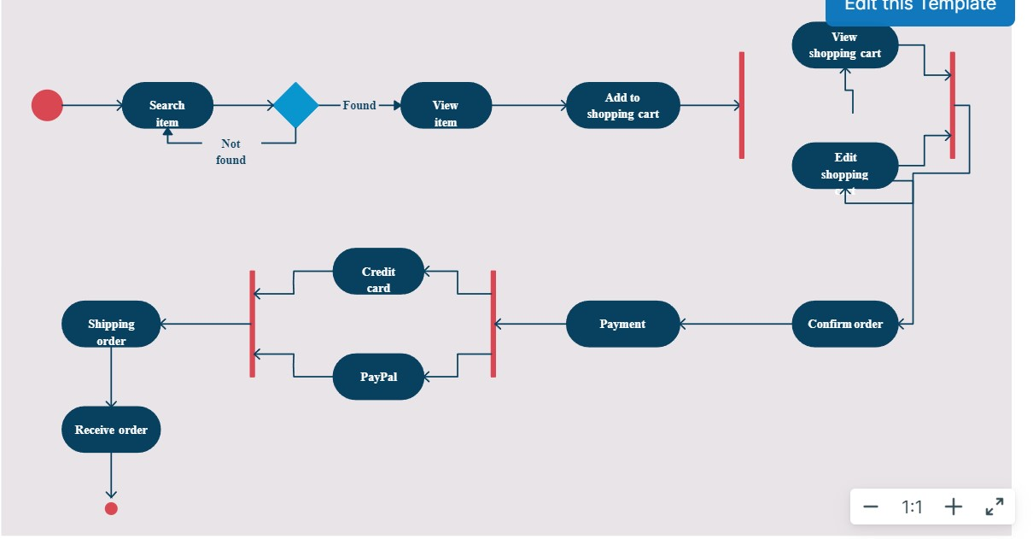

**IMPLEMENTATION**

**HTML FILE:-**

****

**CSS FILE:-**

****

**JAVASCRIPT FILE:-**

****

**IMAGE FILE:-**

**twitter-iconstar-icon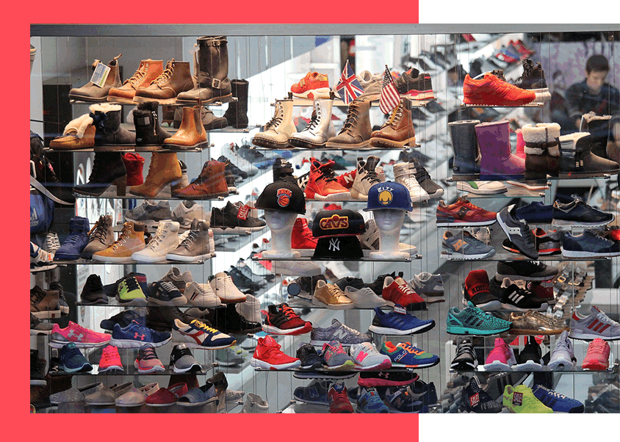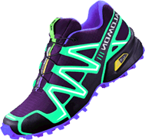search_iconphone-iconmap-iconlogoin-icongoogle-iconfb-iconemail-icon**

**CONCLUSION**

In summary, the creation of an online shopping system with JavaScript, HTML, and CSS is a dynamic combination of design, structure, and interaction. The fundamental structure for content organization is provided by HTML, and the site's responsiveness and aesthetic appeal are improved by CSS. The system is given vitality by JavaScript, which adds interactivity with features like dynamic content updates and a smooth shopping cart experience. The amalgamation of these technologies enables an interface that is easy to use, responsive design that adapts to a range of devices, and the adoption of secure protocols like HTTPS and form validation, all of which contribute to creating a reliable and secure environment for users. The focus on ongoing enhancement, encompassing compatibility testing and user experience optimization, highlights the dedication to providing a stable and delightful virtual shopping encounter. In addition to demonstrating the potential of web technologies, this project emphasizes the value of a comprehensive approach to functionality, design, and security in the dynamic field of e-commerce.

In conclusion, design, functionality, and security must all be considered when creating an online store using HTML, CSS, and JavaScript. Developers can create an efficient and interesting platform for users to browse, choose, and buy goods and services by carefully integrating these technologies.

The use of HTML, CSS, and JavaScript to create an online shopping system shows how useful these web technologies are for building dynamic and user-friendly e-commerce platforms. The website's structural basis is provided by HTML, which also defines the content elements and layout. A consistent and aesthetically pleasant user experience is ensured by CSS, which improves the website's visual appeal and styling. The dynamic behavior and interactivity added by JavaScript makes features like order processing, cart management, and product browsing possible. These technologies work together to enable developers to create scalable, reliable online shopping platforms that satisfy the requirements of both customers and businesses.

**REFERENCES**

Coulter, S. (2017). SHOP TILL YOU DROP: SHOPPING AND CONSUMPTION. In *Everyday Economics: A user’s guide to the modern economy* (pp. 145-170). Agenda Publishing. Retrieved from http://www.jstor.org.ezlibproxy1.ntu.edu.sg/stable/j.ctv5cg7rp.10

Davis, S. (2001). Shopping. In Maxwell R. (Ed.), *Culture Works: The Political Economy of Culture* (pp. 163-196). University of Minnesota Press. Retrieved from http://www.jstor.org.ezlibproxy1.ntu.edu.sg/stable/10.5749/j.cttts95w.9

Gurak, L. (2001). Shopping at the E-Mall. In *Cyberliteracy: Navigating the Internet with Awareness* (pp. 128-144). New Haven; London: Yale University Press. Retrieved from http://www.jstor.org.ezlibproxy1.ntu.edu.sg/stable/j.ctt1nq4x0.11

Hoyer, W.D., McInnis, D.J. Pieters, R. (2013). Consumer Behavior, 6th edition, South-Western Cengage Learning. ISBN 10: 11334435211 ISBN 13: 978-11334435211

****Journal Articles****

Abukhader, S. M., & Jonson, G. (2004). E-commerce and the environment: A gateway to the renewal of greening supply chains. *International Journal of Technology Management,28*(2), 274. doi:10.1504/ijtm.2004.005066

Abukhader, S. M. (2008). Eco-efficiency in the era of electronic commerce – should ‘Eco-Effectiveness’ approach be adopted? *Journal of Cleaner Production,16*(7), 801-808. doi:10.1016/j.jclepro.2007.04.001

Carrillo, J. E., Vakharia, A. J., & Wang, R. (2014). Environmental implications for online retailing. *European Journal of Operational Research,239*(3), 744-755. doi:10.1016/j.ejor.2014.05.038

Candriam Investors Group. (2017). Environmental benefits of E-commerce versus brick-and-mortar retailing: reality or illusion?

Edwards, J. B., Mckinnon, A. C., & Cullinane, S. L. (2010). Comparative analysis of the carbon footprints of conventional and online retailing. *International Journal of Physical Distribution & Logistics Management,40*(1/2), 103-123. doi:10.1108/09600031011018055

Matthews, H., Williams, E., Tagami, T., & Hendrickson, C. T. (2002). Energy implications of online book retailing in the United States and Japan. *Environmental Impact Assessment Review, 22*(5), 493-507. doi:10.1016/s0195-9255(02)00024-0

Weber, C. L., Hendrickson, C. T., Matthews, H. S., Nagengast, A., Nealer, R., & Jaramillo, P. (2009). Life cycle comparison of traditional retail and e-commerce logistics for electronic products: A case study of buy.com. *2009 IEEE International Symposium on Sustainable Systems and Technology*. doi:10.1109/issst.2009.5156681

Weideli, D. (2013). Environmental Analysis of US Online Shopping MIT Center.

****Websites****

Allington, A. (2018, October 05). ‘Overboxing’ Becomes Enemy No. 1 in Amazon-Led Web-Shopping Boom. Retrieved March 22, 2019, from https://www.bna.com/amazon-retailers-redo-n73014483019/

Baker, P. (2018, February). E-commerce packaging waste becoming a bigger issue. Retrieved March 22, 2019, from https://searcherp.techtarget.com/feature/E-commerce-packaging-waste-becoming-a-bigger-issue

Bernstein, R. (2018, June 06). Top Consumer Behavior Theories. Retrieved March 22, 2019, from https://online.husson.edu/consumer-behavior-theories/

Bird, J. (2018, July 29). What A Waste: Online Retail’s Big Packaging Problem. Retrieved March 22, 2019, from https://www.forbes.com/sites/jonbird1/2018/07/29/what-a-waste-online-retails-big-packaging-problem/#30658546371d

Deutschland, A. (2017, March 30). Is online shopping bad for the environment? Retrieved March 22, 2019, from https://www.alumniportal-deutschland.org/en/global-goals/sdg-12-consumption/online-shopping-or-local-shopping-whats-better-for-the-environment/

Faghri, A. (2016, March 11). What’s the environmental impact of your online shopping habits? Retrieved March 22, 2019, from https://www.1millionwomen.com.au/blog/whats-environmental-impact-your-online-shopping-habits/

Giersemehl, F. (2017, December 11). Sustainability in eCommerce: How green is your online shop? Retrieved March 22, 2019, from https://webdata-solutions.com/en/2017/11/10/sustainability-in-ecommerce-how-green-is-your-online-shop/

Hermesauto. (2017, November 17). China faces 160,000 tonnes of packaging waste after Singles’ Day buying binge. Retrieved March 22, 2019, from https://www.straitstimes.com/asia/east-asia/china-faces-160000-tonnes-of-packaging-waste-after-singles-day-buying-binge

Holt, K. (2018, May 09). UPS has new electric trucks that look straight out of a Pixar movie. Retrieved March 22, 2019, from https://www.engadget.com/2018/05/09/ups-electric-trucks-arrival/

Jaller, M. (2018, November 21). Online shopping is terrible for the environment. It doesn’t have to be. Retrieved March 22, 2019, from https://www.vox.com/the-big-idea/2017/12/21/16805324/black-friday-2018-amazon-online-shopping-cyber-monday-environmental-impact

Murdock, A., & University of California. (2017, November 17). The environmental cost of free 2-day shipping. Retrieved March 22, 2019, from https://www.vox.com/2017/11/17/16670080/environmental-cost-free-two-day-shipping

Peters, A. (2018, September 12). Your UPS deliveries may soon arrive in electric trucks. Retrieved March 22, 2019, from https://www.fastcompany.com/90229460/your-ups-deliveries-may-soon-arrive-in-electric-trucks

Segran, E., & Segran, E. (2019, February 05). Your online shopping has a startling hidden cost. Retrieved March 22, 2019, from https://www.fastcompany.com/90301638/your-online-shopping-has-a-startling-hidden-cost

Sottile, C. A., & Jo, L. (2017, June 18). Sure, you love shopping online. But where does all that cardboard go? Retrieved March 22, 2019, from https://www.nbcnews.com/business/consumer/all-online-shopping-has-cardboard-consequences-n773656

Verdon, J. (2018, November 21). Is it better for the environment to shop online or in-store? Retrieved March 22, 2019, from https://www.northjersey.com/story/money/2018/11/20/green-shopping-environment-online-store/2011689002/

Wicker, A. (2019, January 31). Online shopping will never be sustainable. Blame these ubiquitous plastic bags. Retrieved March 22, 2019, from https://www.vox.com/the-goods/2019/1/31/18203972/polybags-plastic-online-shopping-meal-kits-patagonia

Zheng, J., & Wang, Y. (2016, April 09). Trash from packaging of online products poses threat. Retrieved March 22, 2019, from http://www.chinadaily.com.cn/china/2016-04/09/content\_24393971.htm

****Pictures****

Online shopping header. (2013). Retrieved March 22, 2019, from https://www.contegix.com/emerging-technologies-new-tactics-to-track-shoppers/

Growth of Global Retail E-commerce Sales (2019-2021 are forecasted). (2019). Retrieved March 22, 2019, from https://www.statista.com/statistics/379046/worldwide-retail-e-commerce-sales/

Growth of Retail E-commerce Sales in Singapore from 2017 to 2023 (2019-2023 are forecasted). (2019). Retrieved March 22, 2019, from https://www.statista.com/outlook/243/124/ecommerce/singapore

Global warming. (2018). Retrieved March 22, 2019, from https://blogs.ufv.ca/science/2018/10/03/greenspeak-series-climate-change/

Effects of global warming. (n.d.). Retrieved March 22, 2019, from https://climate.nasa.gov/resources/global-warming/

Failed crops due to drought. (2015). Retrieved March 22, 2019, from https://www.standardmedia.co.ke/article/2000182333/kenyan-farmers-to-get-crop-failure-insurance-cover

Garhi Mendu Village Residents shift to safe places in a flooded locality near Yamuna River in New Delhi. (2013). Retrieved March 22, 2019, from https://www.dailymail.co.uk/indiahome/indianews/article-3694584/Delhi-residents-72-hour-flood-warning-Low-lying-areas-face-evacuation-Haryana-drains-water-Hathini-Kund-Barrage-Yamuna.html

Plastic and cardboard packaging. (2016). Retrieved March 22, 2019, from https://www.1millionwomen.com.au/blog/whats-environmental-impact-your-online-shopping-habits/

Bubble wrap. (n.d.) Retrieved March 22, 2019, from https://commons.wikimedia.org/wiki/File:Bubble\_Wrap.jpg

Plastic air padding. (n.d.). Retrieved March 22, 2019, from https://www.cnpackbest.com/air-packing-roll/air-column-roll/reusable-shockproof-delivery-packaging-air.html

Cyber Monday was on track to become the biggest-ever internet shopping day in the United States. (2017). Retrieved March 22, 2019, from https://www.express.co.uk/finance/city/885298/cyber-monday-black-friday-amazon-alibaba-group-wal-mart-biggest-ever-online-shopping-day

Cardboard waste. (2018). Retrieved March 22, 2019, from https://www.forbes.com/sites/jonbird1/2018/07/29/what-a-waste-online-retails-big-packaging-problem/#6d3d3e42371d

Injured turtle with a 12cm plastic straw stuck up its nose. (2018). Retrieved March 22, 2019, from https://www.standard.co.uk/news/uk/the-last-straw-footage-of-a-turtle-with-a-12cm-plastic-straw-stuck-up-its-nose-highlights-the-a3740136.html

Electric vehicles. (2018). Retrieved March 22, 2019, from https://www.fastcompany.com/90229460/your-ups-deliveries-may-soon-arrive-in-electric-trucks

POPStation in Singapore. (n.d.). Retrieved March 22, 2019, from https://www.mypopstation.com/locations?area=west’

Reusable crate. (n.d.) Retrieved March 22, 2019, from http://brutebox.com/moving-supplies/reusable-moving-boxes

Planning before purchase. (2018). Retrieved March 22, 2019, from https://searchengineland.com/the-40-point-seo-checklist-for-startups-296197